Food Insecurity and its Impact on Persons with Disabilities
Key Issues across the Horn of Africa and Southern Madagascar
Policy Paper for Swiss humanitarian actors
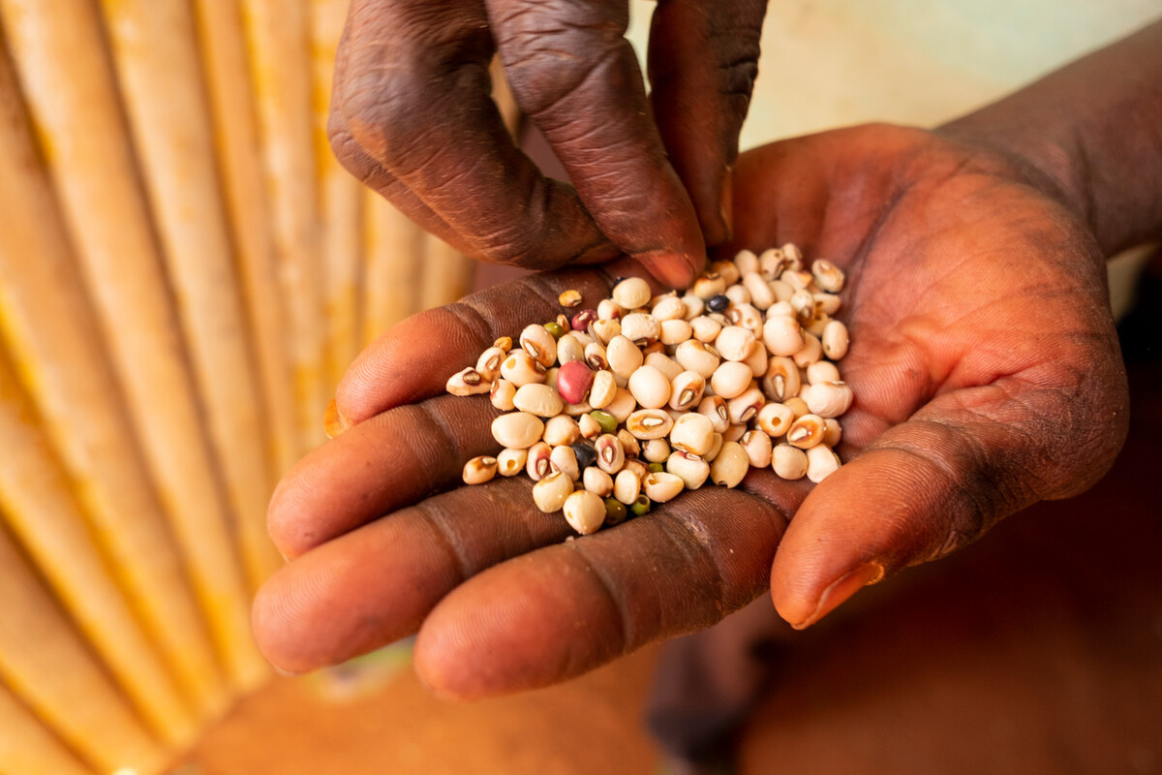
©CBM/Hayduk
September 2022

Recommendations
Considering the barriers persons with disabilities face during humanitarian response and to ensure no one is left behind, we urge all partners and especially the Swiss government to undertake urgent action to address the acute food insecurity:
- We call on all humanitarian actors including Swiss humanitarian aid to ensure their humanitarian food response is accessible to and inclusive of persons with disabilities:
- Take measures to ensure that cash-based interventions are inclusive for persons with disabilities.
- Contribute to improved access to assistive technology, including assistive devices and support services including referral to these.
- Provide budget for reasonable accommodation (2–3% of a budget) and to cover extra costs of disability.
- Conduct community sensitization and capacity building on rights, address awareness, information barriers and stigma on persons with disabilities.
- Proactively consult and meaningfully involve persons with disabilities in decision-making and planning processes including their representative organizations (OPDs) and assistants (often mothers).
- We call on the Swiss government to provide additional financial assistance to upscale its humanitarian aid and to increase the financial framework of official development assistance (ODA) to 0.7% of the gross national income as required by the UN to meet the needs of all affected populations during food responses, including persons with disabilities.
- We call on Switzerland to champion disability inclusion during its upcoming presidency of the Security Council 2023–2024, by calling for adherence to Security Council resolution 2475, ensuring the meaningful participation of persons with disabilities and their representative organizations in the peace continuum including in conflict prevention, resolution, reconciliation, reconstruction and peacebuilding.
- We call on Switzerland to include persons with disabilities in disaster mitigation and preparedness, including for sudden and slow onset disasters linked to climate change.
- We call on the Swiss government to review the extraterritorial impact of its actual approach to corporate taxation, to financial secrecy and to debt burdens associated with private creditors. The review should focus particularly on the impact on people experiencing the most extreme inequalities, including persons with disabilities, and should align fully with human rights obligations including the CRPD.

Context
Three key drivers are responsible for the rise in global food insecurity: First, conflicts reduce people’s access to food by destroying their livelihood and causing displacement. Secondly, the globalization of food production and of the international economy significantly increase the fragility of global food systems and have a negative impact on local production. These circumstances strongly limit food sovereignty in the Global South, leading to increased dependency on the global economy. Therefore, economic shocks, such as those caused by the COVID-19 pandemic, raise food insecurity even more. This is due to exacerbated inequalities across and within countries, an uneven economic recovery across countries and continued economic fallout for many people. And thirdly, due to climate change, extreme weather events like the long-lasting droughts in East Africa and Southern Madagascar occur more frequently and undermine people’s ability to feed themselves and their families.
These drivers overlap, interlink and mutually reinforce each other in many countries that CBM Global works in. They have led to rising food prices worldwide in recent years. The war in Ukraine worsened an already difficult situation. People across the horn of Africa (Somalia, Ethiopia, Kenya) are hit hard by famine. If it doesn’t start to rain and food prices continue to rise, the number of people affected by hunger is estimated to rise from 14 to 20 million in this area. Also, in Southern Madagascar, people continue to face high levels of acute food insecurity, largely due to the severe drought. The World Food Programme (WFP) states, that the gap between needs and funding is bigger than ever before.
Food security is a priority of Switzerland’s international cooperation strategy 2021–2024: The Global Programme on food security aims to contribute to sustainable and resilient food systems and considers “Leave No One Behind” as a transversal issue. The financial resources of the Global Programme on food security shall be CHF 251 million for 2021–2024. Improving food security and livelihoods is also a key component of Switzerland’s humanitarian aid. In March 2022 for example, Switzerland contributed CHF 10.8 million to address the drought in Somalia and Ethiopia. Besides this approach to food security in Switzerland’s international cooperation, Switzerland also impacts countries’ ability to respond to such crises due to its policies on corporate taxation, financial secrecy and debt burdens. Having ratified the Convention on the Rights of Persons with Disabilities and signed onto the Charter on Inclusion of Persons with Disabilities in Humanitarian Action, Switzerland is committed to making its humanitarian action inclusive of persons with disabilities. So far, only few concrete steps have been taken to implement these instruments.
Persons with disabilities are particularly affected by food insecurity: they are more likely to live in poverty and more likely to be subjected to hunger or to live in food insecure households – especially women with disabilities. However, persons with disabilities are only rarely considered in research on food insecurity and if so, social and environmental barriers to access food, such as norms, policies or the physical environment, are often ignored. Furthermore, the collection of data on persons with disabilities is rarely a priority when governments and civil society organizations respond to emergency situations. Without relevant data, it is difficult to have a good understanding of the situation persons with disabilities face. As a result, humanitarian interventions and development programmes rarely take their rights and situation into account, pushing them even further behind and at-risk.

Barriers to achieving inclusive food security responses
Experience from CBM Global in Kenya and Southern Madagascar show that persons with disabilities face barriers in all dimensions of accessibility during humanitarian responses targeting food insecurity. Addressing them is key to leaving no one behind:

Attitudes and behaviour
Due to stigmatization, persons with disabilities are often excluded from decision-making processes at community level, and therefore not consulted nor involved in decision-making processes during project design and implementation. In turn, their needs and situation are not taken into account. There is also intersectional discrimination as the decision-making processes are often dominated by the elderly men of the communities, disregarding the opinions of young persons and women.

Information and communication
Inaccessible communication of information can be a key barrier for persons with disabilities. Accessible communication – e.g. informing about food distribution door-to-door – or the use of different means of communications isn’t ensured. Persons with disabilities are often not able to access the registration process and as a result, are excluded from food distribution.

Infrastructure and services
Inaccessible transport can also be a barrier for persons with disabilities. Persons with disabilities, especially those not able to leave their homes for example, cannot travel to registration centres for cash assistance, and therefore aren’t considered in many humanitarian responses. Another reason why persons with disabilities do not make it to the registration centres, may be the lack of assistive devices enabling them to go there. It is often a structural problem; the state fails to provide for assistive devices, leaving persons with disabilities behind. This also affects their access to the market and their ability to buy food. Since food prices have been rising, there is less money available for medical needs. For those needing medication, it is an impossible choice to make between food and water, or medication.

Institutional
There are also administrative barriers such as the need for an identity card or a minimum age to receive humanitarian assistance. This is especially true for persons with disabilities whose births have not been registered. Furthermore, ensuring that cash transfers as well as food and non-food-items reach the right person is particularly difficult. If persons with disabilities have to rely on family members or neighbours to access their cash transfer, there is a risk that they keep the money for themselves instead of handing it over to the person with a disability – as they are often in difficult situations themselves.

Bibliography

Caritas Switzerland. 2022. Caritas-Positionspapier zur Hungerkrise im Globalen Süden Weltweite Mehrfachkrise – die Schweiz muss dringend handeln. https://www.caritas.ch/ fileadmin/user_upload/Caritas_Schweiz/data/site/was-wir-sagen/unsere-position/ positionspapiere/2022/Positionspapier_Auswirkungen_Ukrainekrieg_arme_Laender_D_Internet_220628.pdf.
WFP and FAO. 2022. Hunger Hotspots. FAO-WFP early warnings on acute food insecurity: June to September 2022 Outlook. Rome, p. 6, 8. https://docs.wfp.org/api/ documents/WFP-0000139904/download/?_ga=2.13574004. 2134344741.1654890341-67065628.1637678351.
CBM Switzerland is a member of CBM Global.
WFP. 2022. No rain and no resources; millions of families across the horn of Africa pushed closer to catastrophe each day. https://www.wfp.org/news/no-rain-and-no-resources-millions-families-across-horn-africa-pushed-closer-catastrophe-each.
Ibid.
WFP. 2022. A Global Food Crisis. https://www.wfp.org/global-hunger-crisis.
Swiss Confederation. 2020. Dispatch on Switzerland’s strategy on international cooperation 2021-2024. https://www.eda.admin.ch/dam/deza/de/documents/aktuell/ dossiers/Botschaft-IZA-2021-2024_DE.pdf.
Swiss Agency for Development and Cooperation. 2020. Global Programme Food Security. Programme Framework 2021–2024. https://www.eda.admin.ch/content/dam/ deza/fr/documents/publikationen/Diverses/Programme_Framework_2021-24_Global_Programme_Food_Security_en.pdf.
Ibid.
Swiss Confederation. 2020. Dispatch on Switzerland’s strategy on international cooperation 2021–2024. https://www.eda.admin.ch/dam/deza/de/documents/aktuell/ dossiers/Botschaft-IZA-2021-2024_DE.pdf.
Federal Department of Foreign Affairs. 2022. Drought in Horn of Africa: Switzerland announces new funding to help people in Somalia and Ethiopia. https://www.eda.admin. ch/deza/en/home/sdc/aktuell/news.html/content/eda/en/meta/news/2022/3/25/87746.
Meeks Polly. 2022. How far do Switzerland’s policies on financing for development (particularly tax and debt) promote rights and equality of persons with disabilities? Fact sheet. P. 13. https://www.cbmswiss.ch/fileadmin/user_upload/Dokumente/Unsere_ Arbeit/Politische_Arbeit/Events/financing-for-development-factsheet-switzerland.pdf.
UN Department of Economic and Social Affairs. 2018. Realization of the sustainable development goals by, for and with persons with disabilities. UN Flagship Report on Disability and Development 2018. P. 57, 62. https://www.ohchr.org/sites/default/files/ Documents/HRBodies/CRPD/UN2018FlagshipReportDisability.pdf; IDS & AFS. 2020. Network Paper: Leave no one behind in practice. P. 4. https://issuu.com/zoienvironment/docs/working-aid-agriculture.
Schwartz Naomi, Buliung Ron, Wilson Kathi 2019. Disability and food access and insecurity: A scoping review of the literature. In: Health and Place 57. P. 107–108. https://www.sciencedirect.com/science/article/pii/S1353829218304386.
CBM Global & Global Greengrants Fund. 2022. Case Study. Climate Change and Its Humanitarian Consequences. The Impact on persons with disabilities in Southern Madagascar. P. 5. https://cbm-global.org/wp-content/uploads/2022/08/Climate-Change-and-its-Humanitarian-Consequences-1.pdf.
UN Department of Economic and Social Affairs. 2018. Realization of the sustainable development goals by, for and with persons with disabilities. UN Flagship Report on Disability and Development 2018. P. 68. https://www.ohchr.org/sites/default/files/ Documents/HRBodies/CRPD/UN2018FlagshipReportDisability.pdf; International Disability Alliance (IDA). 2018. Disability and Food Security: an unfinished Policy Agenda. https://www.internationaldisabilityalliance.org/fao-food-insecurity.
CBM Global & Global Greengrants Fund. 2022. Case Study. Climate Change and Its Humanitarian Consequences. The Impact on persons with disabilities in Southern Madagascar. P. 6. https://cbm-global.org/wp-content/uploads/2022/08/Climate-Change-and-its-Humanitarian-Consequences-1.pdf.
Ibid. Contact: CBM Switzerland Schützenstrasse 7 8800 Thalwil desiree.zaugg@cbmswiss.ch

